**Vespa Navigation Exercise**

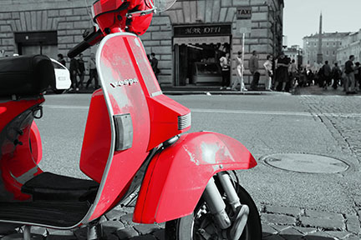

Use the images and text provided to create a home page for Vespa. You will need to include the following:

1. Red Vespa image as a background
2. Title VESPA on the main image
3. Conventional text navigation using the code provided (how you place and style is up to you)
4. Add three hot spots identified by the round pictures. When viewer hovers over a round picture the following text boxes appear. (location is up to you make sure they are readable) You are free to edit images as you wish.

**TECH POWER**

THE TECHNOLOGY OF THE VESPA PRIMAVERA HAS BEEN DEVELOPED FOR A BETTER WORLD., IT MARKS A STEP FORWARD, WHICH EXTENDS TO TECHNOLOGICAL CONTENT AND CONSTRUCTION QUALITY

# GLOBAL STYLE

THE RETURN OF THE PRIMAVERA, DESIGNED BY FUTURE! THE DISTINGUISHING FEATURE IS THE NEW BODY, WITH A HOST OF NEW FEATURES AND EVEN GREATER END QUALITY.

# SAFETY FIRST

TECHNOLOGY MEANS LITTLE UNLESS IT PROTECTS THE RIDER. SAFETY IS A KEY CONCERN FOR THE VESPA PRIMAVERA, WITH ENHANCED RIDING PLEASURE AND COMFORT.

Upload completed exercise to your portal. Image Map/Navigation

Here’s typical css style for placing image, placing text and making text appear when you hover over image. Your positioning locations will of course be different.

**place image and text <figure id=box_one><img src=pict.jpg><p>text</p></figure>**

#box_one {position: absolute;

top: 80px;

left:420px;}

**text positioned but not visible**

#box_one p{position: absolute;

top: 15px;

left:0px;

width: 100px;

display:none;}

**style text and make it visible when you hover over image**

#box_one:hover p {display: block;

font-family: verdana;

font-size: 14px;

color: white;

font-weight: bold;

line-height: 90%;

text-align: center;}